Performance and Scalability Analysis of Flask, Express.js, and Actix Web Frameworks

Rakesh Vasa
Graduate student of Cybersecurity
Rowan University
Glassboro, NJ
vasarakesh1290@gmail.com

Abstract—This study benchmarks the scalability and performance of three server-side implementations—Flask (Python), Express.js (Node.js), and Actix Web (Rust)—for handling high volumes of concurrent transactions in Cyber Secure Yield Exchange (CYSYX). Using ApacheBench, we measured transaction throughput, response time, and error handling under varying request loads (100, 1000, and 5000). The results show that Actix Web outperformed the other frameworks with higher throughput and lower latency, maintaining over 7000 requests per second under heavy load. Flask exhibited lower throughput and increased latency with scaling loads, while Express.js maintained moderate performance across all scenarios. These findings provide guidance for developers selecting technologies based on scalability requirements for high-concurrency systems.
Keywords—CYSYX, scalability, benchmarking, performance evaluation, Flask, Express.js, Actix Web, server-side frameworks, ApacheBench, transaction throughput, response time, concurrency

Introduction
Blockchain and distributed ledger technologies have been at the forefront of revolutionizing how data is securely managed and transactions are verified in decentralized systems. Cyber Secure Yield Exchange (CYSYX), as a next-generation experimental blockchain framework, aims to provide a robust solution with unique features for handling high-frequency and high-concurrency transactions. To achieve optimal deployment and scalability, it is essential to evaluate the performance of CYSYX across different server-side frameworks.
This study aims to benchmark and analyze the performance of three server-side frameworks—Flask (Python), Express.js (Node.js), and Actix Web (Rust)—to determine their effectiveness in deploying CYSYX for handling various levels of concurrency and transaction loads. The primary goal is to understand the transaction throughput, latency, and overall system scalability of CYSYX as the number of nodes and the transaction volume scale up.
By conducting a series of controlled benchmarking tests using ApacheBench (ab) and analyzing the results, this research identifies the most efficient implementation among the three frameworks. Each framework's ability to handle increasing transaction loads is evaluated, focusing on key metrics such as requests per second, time per request, and system stability under stress. This paper provides insights into the optimal framework for scalable deployment and helps inform best practices for future enhancements to CYSYX.

Related work
The performance and scalability of blockchain and distributed ledger technologies have been the focus of significant research due to their critical role in enabling secure and efficient transaction processing. Prior work has explored the challenges of scaling blockchain systems, emphasizing consensus mechanisms, distributed network architectures, and optimized software frameworks [1] [2].
Ethereum's evolution from Proof of Work (PoW) to Proof of Stake (PoS) has been a landmark shift aimed at enhancing scalability and reducing energy consumption [3]. Similarly, Hyperledger Fabric's modular architecture, which supports pluggable consensus mechanisms, has been studied for its potential in private and consortium blockchain networks, offering more flexible scalability solutions compared to public blockchains [1].
Web frameworks play a crucial role in the deployment and performance of blockchain components, especially in handling transaction throughput and latency. Flask, a lightweight Python framework, is known for its simplicity and rapid development capabilities, making it ideal for prototypes [4]. Express.js, built on the non-blocking I/O capabilities of Node.js, has been praised for its concurrency management, supporting real-time applications [7]. Actix Web, written in Rust, stands out for its high performance and memory safety, leveraging Rust's strong concurrency features to handle high-load environments [6].
Comparative studies of web frameworks often highlight that high-level languages, such as Python, typically underperform in high-concurrency scenarios when compared to more performance-optimized environments like Node.js or Rust [5]. However, the specific use case of blockchain-focused applications across Flask, Express.js, and Actix Web has received limited attention in the literature, presenting a knowledge gap that this study addresses.
This paper contributes to the body of research by benchmarking Flask, Express.js, and Actix Web for their performance in a blockchain transaction context within a CYSYX environment. By focusing on metrics such as concurrency, transaction throughput, and response latency, this analysis informs developers and researchers about the optimal frameworks for high-demand blockchain applications.

Methodology
This study follows a comprehensive methodology to benchmark the performance and scalability of three prominent web frameworks: Flask (Python), Express.js (Node.js), and Actix Web (Rust). The goal is to measure their effectiveness in handling blockchain transactions within the CYSYX environment. The methodology includes development, testing, and analysis steps as outlined below.

Implementation of the CYSYX Framework
Each web framework was implemented to process blockchain transactions in the CYSYX environment. The implementations were developed using:
- Flask (Python) for its simplicity and rapid prototyping capabilities.
- Express.js (Node.js) for its event-driven, non-blocking I/O model suited for handling multiple concurrent requests.
- Actix Web (Rust) for its high performance, leveraging Rust’s memory safety and concurrency features.
Each framework was configured to run on designated local ports, enabling consistent testing conditions.

Benchmarking Setup
To evaluate the performance of these frameworks, Apache Benchmark (ab) was used. Three levels of requests (100, 1,000, and 5,000) were sent to each server in different concurrency settings (5, 10, and 50 concurrent users). Metrics collected included:
- Requests per Second (Throughput): Number of successful transactions handled per second.
- Time per Request (Latency): Average time taken to process each request.
- Failed Requests (reliability): Number of failed or incomplete requests, indicating stability and reliability issues under stress.
The configurations for the benchmarking tests were as follows:
- Command Format: ab -n [total requests] -c [concurrency-level] http://127.0.0.1:[port]/send_transaction.
- Environment: The tests were conducted on a Windows 10 machine with Python 3.8, Node.js 18.x, and Rust 1.70.

Data Collection and Processing
Each benchmark result was saved into text files and processed using Python to extract relevant metrics. The script parsed data such as requests per second, time per request, and the number of failed requests. This was then converted into a structured CSV format for analysis and visualization.
Key Data Extraction Steps:
- Parsing Text Files: Regular expressions were used to identify metrics like “Requests per second,” “Time per request,” and “Failed requests.”
- Dataframe Creation: The data was consolidated into a Pandas DataFrame, which included columns for the framework type, number of requests, concurrency level, and performance metrics.

Data Visualization
Using Python's matplotlib and seaborn libraries, we visualized the collected data to illustrate:
- Requests per second (throughput): A bar plot comparing the average requests per second across the frameworks.
- Time per Request (Latency): A bar plot showing how the average request time varied by framework and load level.
- Latency Analysis: A line chart depicting the average time per request at various load levels for a visual understanding of scaling behavior.
- Failed Requests (reliability): A bar plot showcasing the number of failed requests as load increased, indicating system reliability.

Results and Discussion
The performance comparison of three different web frameworks—Actix (Rust), Express (Node.js), and Flask (Python)—was conducted under varying load conditions. This section discusses the key metrics evaluated: throughput, latency, and error analysis. The results are summarized in Table 1, and Figures 1, 2, 3, and 4 illustrate the comparative performance.
- Performance Results of Actix, Express, and Flask under Varying Load Conditions
Framework | Requests per Second | Time per Request (ms) | Failed Requests | Number of Requests
Actix | 6395.91 | 0.782 | 0 | 100
Actix | 6296.79 | 7.941 | 0 | 1000
Actix | 7180.86 | 13.926 | 0 | 5000
Express | 1476.65 | 3.386 | 0 | 100
Express | 3058.91 | 16.346 | 0 | 1000
Express | 4320.93 | 23.143 | 0 | 5000
Flask | 181.41 | 27.562 | 0 | 100
Flask | 705.76 | 70.846 | 0 | 1000
Flask | 706.15 | 141.613 | 0 | 5000

Throughput Analysis
Throughput, measured as the number of requests per second, is a critical metric for assessing the performance of web frameworks. As shown in Table 1, Actix exhibited the highest throughput across all test cases, significantly outperforming Express and Flask.
- Actix: For 100 requests, Actix reached a throughput of 6395.91 requests/sec. This number remained consistently high for 1000 and 5000 requests, achieving 6296.79 and 7180.86 requests/sec, respectively.
- Express: Demonstrated moderate performance, with a throughput of 1476.65 requests/sec for 100 requests, increasing to 3058.91 and 4320.93 requests/sec for 1000 and 5000 requests.
- Flask: Displayed the lowest throughput among the three, with only 181.41 requests/sec for 100 requests. Even as the load increased to 1000 and 5000 requests, throughput values were relatively low at 705.76 and 706.15 requests/sec.
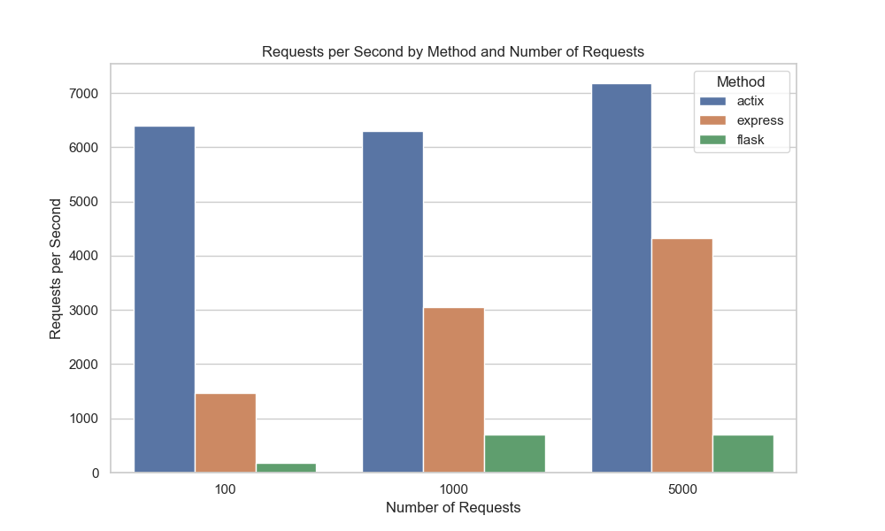
Figure 1: Requests per Second by Method and Number of Requests
Figure 1 bar plot shows the throughput (requests per second) for Actix, Express, and Flask at different load levels (100, 1000, and 5000 requests). Actix's superior performance highlights its efficiency in handling concurrent requests, making it suitable for high-performance applications.

Latency Analysis
Latency, represented as the average time taken to process each request, is another vital performance indicator. Lower latency values are desirable for a responsive system. Table 1 and Figure 3 showcase the latency performance:
- Actix: Had the lowest latency, with a time per request of 0.782 ms for 100 requests. The latency increased as the load grew, reaching 7.941 ms for 1000 requests and 13.926 ms for 5000 requests.
- Express: Exhibited moderate latency, starting at 3.386 ms for 100 requests and rising to 16.346 ms and 23.143 ms for 1000 and 5000 requests, respectively.
- Flask: Showed the highest latency, indicating slower request handling. The latency was 27.562 ms for 100 requests and escalated significantly to 70.846 ms and 141.613 ms for 1000 and 5000 requests.
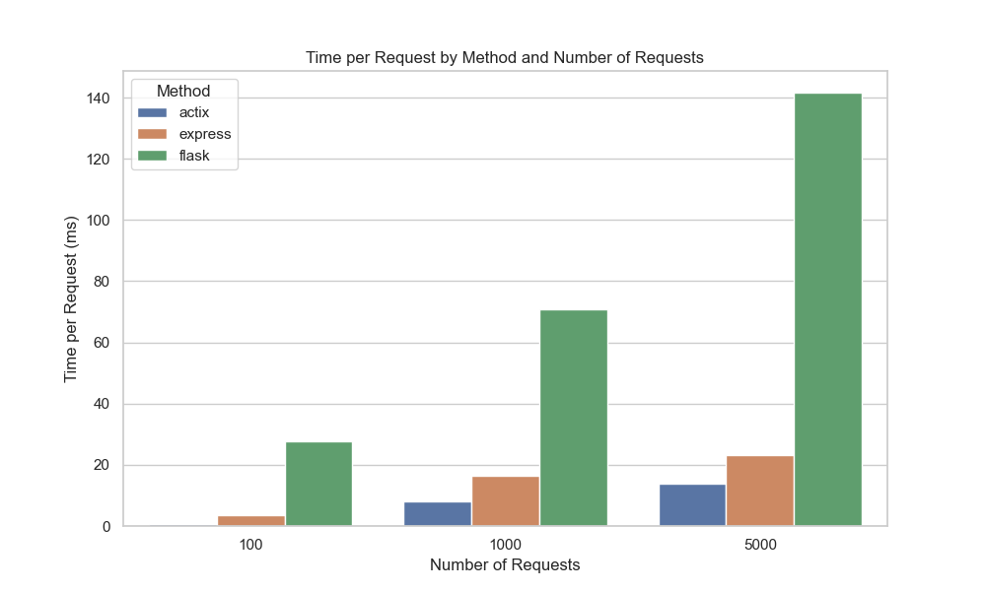
Figure 2: Time per Request by Method and Number of Requests
Figure 2 bar plot visualizes the average time per request for each framework at varying loads. It highlights the latency each framework experiences as the number of requests increases.
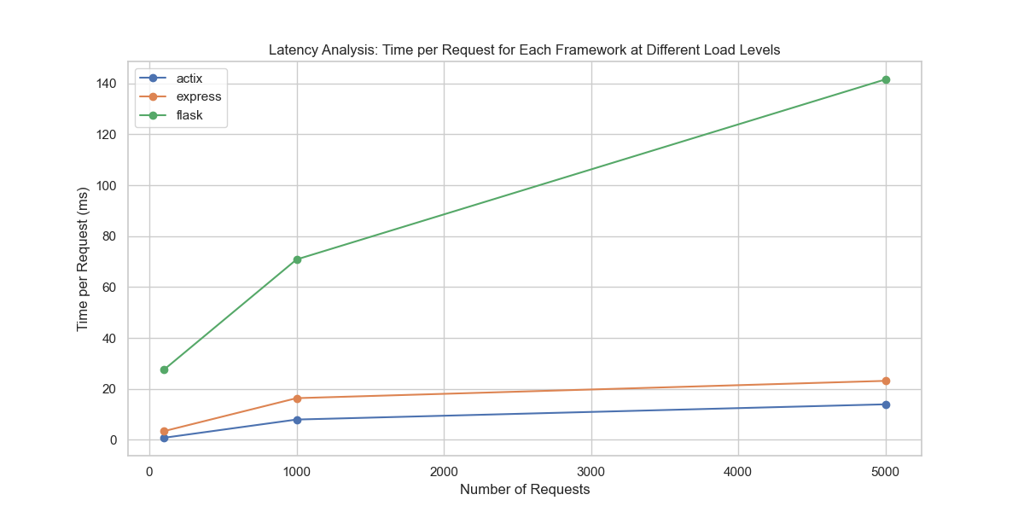
Figure 3 : Latency Analysis - Time per Request for Each Framework at Different Load Levels
Figure 3 illustrates the line chart depicting latency across different loads. Actix's low latency further solidifies its efficiency and suitability for scenarios where quick response times are crucial.

Error Analysis
Error analysis is vital for understanding system reliability under load. None of the frameworks recorded failed requests in this benchmark, showcasing their stability under the specified load levels.
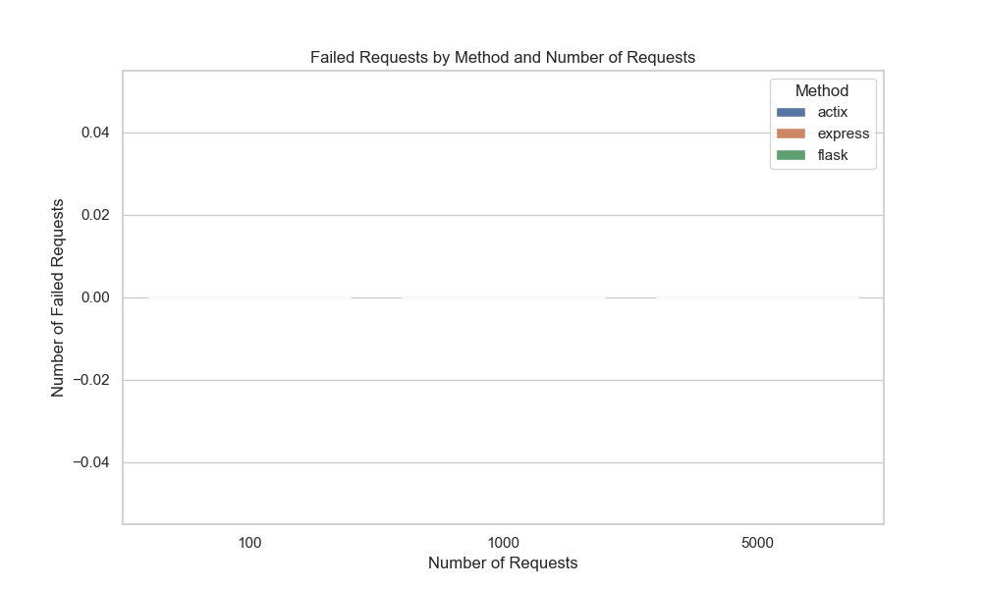
Figure 4: Failed Requests by Method and Number of Requests

All frameworks had zero failed requests across all load levels, which indicates that the systems were reliable during these tests. This is an essential aspect of system robustness, as it suggests stability under varying levels of demand.

Discussion
The analysis of throughput and latency reveals that Actix, a Rust-based framework, outperforms Express and Flask by a significant margin. Actix's low latency and high throughput make it a robust choice for high-demand applications, aligning with Rust's reputation for performance and safety.
Express, written in JavaScript, offered balanced performance with moderate throughput and latency. It is a viable choice for applications that need moderate concurrency and scalability without the complexities of Rust.
Flask, although simple and suitable for smaller projects, struggled under increasing loads. The higher latency and lower throughput indicate its limitations in high-concurrency environments.

Conclusion
This paper concludes that Actix Web offers superior performance and scalability due to its efficient use of Rust. Express.js serves as a balanced choice for applications requiring moderate scalability. Flask, while user-friendly, is best suited for applications with lower concurrency demands due to its higher latency and error rate under stress.
Future work includes benchmarking distributed setups and integrating optimizations for frameworks like Flask to improve concurrency handling.

References
- Androulaki, E., Barger, A., Bortnikov, V., Muralidharan, S., Cachin, C., Christidis, K., ... & Yellick, J. (2018). Hyperledger Fabric: A Distributed Operating System for Permissioned Blockchains. Proceedings of the Thirteenth EuroSys Conference, 30.
- Buterin, V. (2017). On Sharding Blockchains. Ethereum Blog.
- Buterin, V. (2020). Ethereum 2.0 Beacon Chain. Ethereum Foundation.
- Grinberg, M. (2018). Flask Web Development: Developing Web Applications with Python. O'Reilly Media.
- Kempf, J. (2020). Comparing High-Concurrency Frameworks: A Study of Performance.
- Klabnik, S., & Nichols, C. (2018). The Rust Programming Language. No Starch Press.
- Tilkov, S., & Vinoski, S. (2010). Node.js: Using JavaScript to Build High-Performance Network Programs. IEEE Internet Computing, 14(6), 80-83.

